1. Create a page named *index.php* page as following.

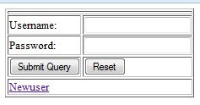

1. Create a *registration.php* page for registration process of a new user as following with following validations.

Validations:

* User Name cannot be empty and of less than 11 characters.
* Passwords fields cannot be empty and both must be same of length 6 to 10.
* For gender selection only one option can be opted.

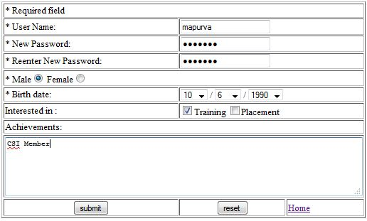

1. After user submits data, user is redirected to *notification.php* page with following display.

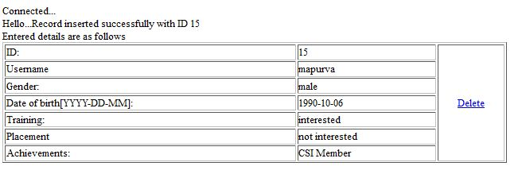

1. When user clicks on delete link, user record is deleted and message is displayed on *index.php* page as following.

